DATA DESCEIPTION:

I HAVE CHANGE THE DATASET LINK:

<https://us3.ca.analytics.ibm.com/bi/?perspective=ca-modeller&id=2359164294_e48736e768cd4b2b9f2df43e778083a4_sessionTemp&objRef=&tid=2359164294_e48736e768cd4b2b9f2df43e778083a4_sessionTemp>

DASHBOARD:

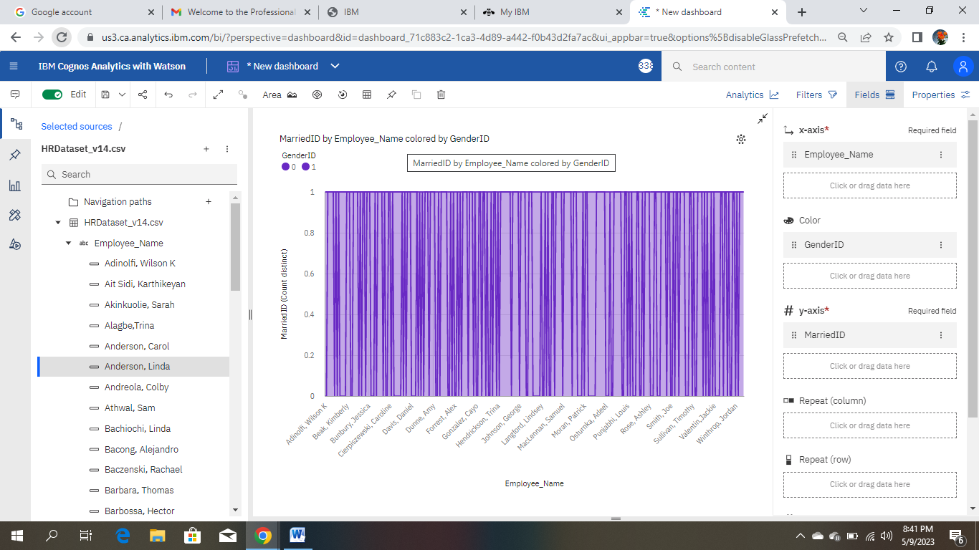

LINK: <https://us3.ca.analytics.ibm.com/bi/?perspective=dashboard&pathRef=.my_folders%2FNew1&action=view&mode=dashboard&subView=model0000018804cf63db_00000000>

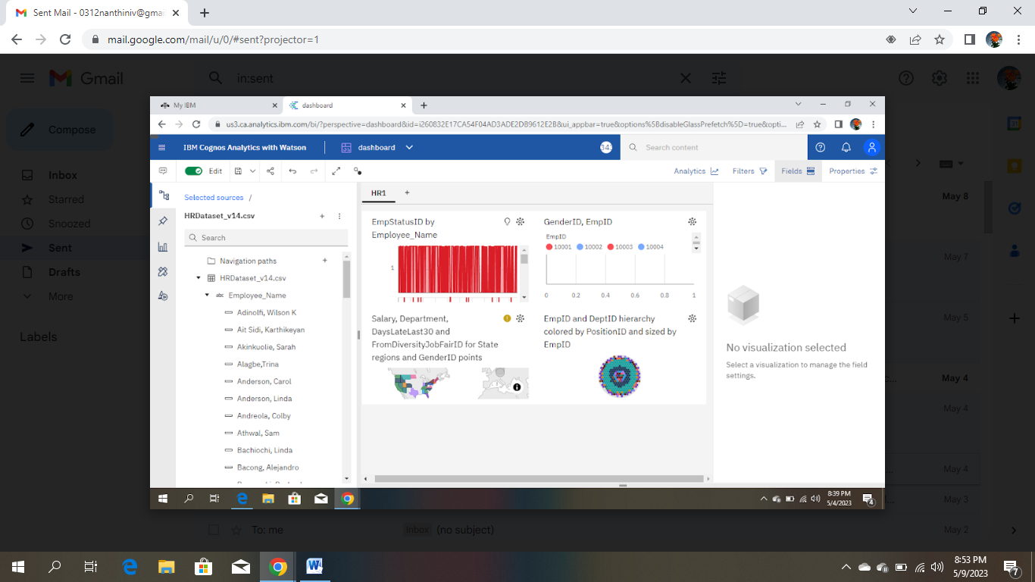

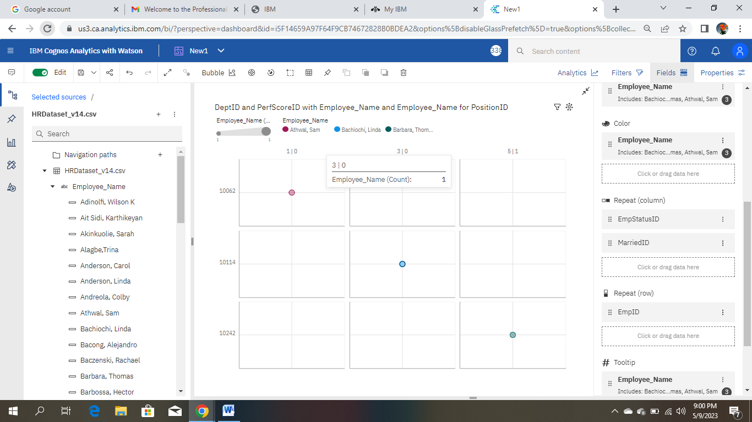

LINK: <https://us3.ca.analytics.ibm.com/bi/?perspective=dashboard&pathRef=.my_folders%2FNew1&action=view&mode=dashboard&subView=model0000018804cf63db_00000000>

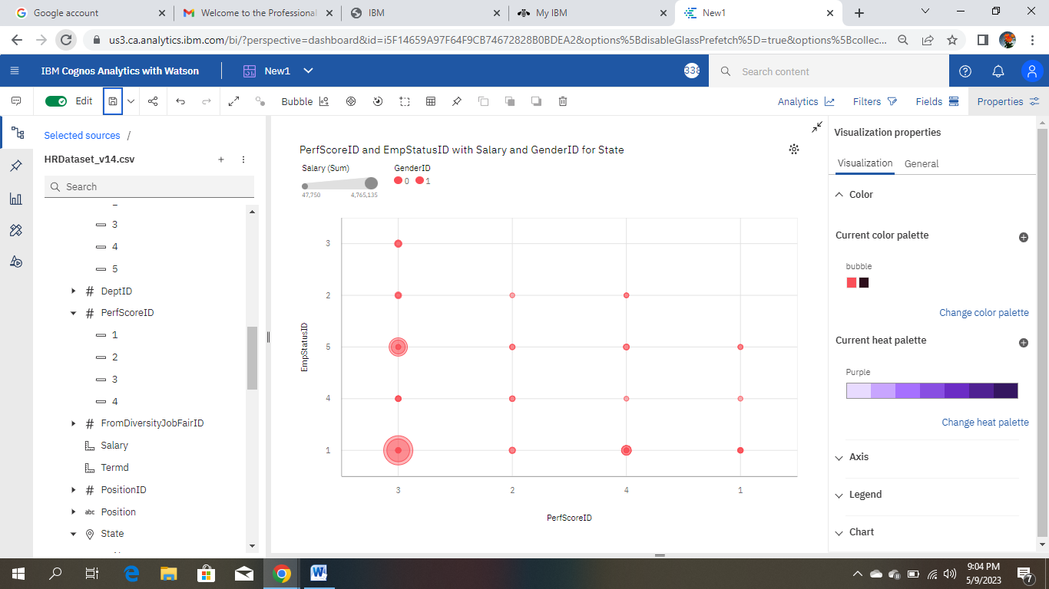

LINK: <https://us3.ca.analytics.ibm.com/bi/?perspective=dashboard&pathRef=.my_folders%2FNew1&action=view&mode=dashboard&subView=model0000018804cf63db_00000000>

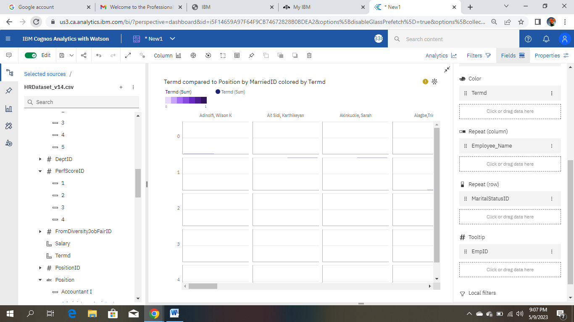

LINK: <https://us3.ca.analytics.ibm.com/bi/?perspective=dashboard&pathRef=.my_folders%2FNew1&action=view&mode=dashboard&subView=model0000018804cf63db_00000000>

REPORT:

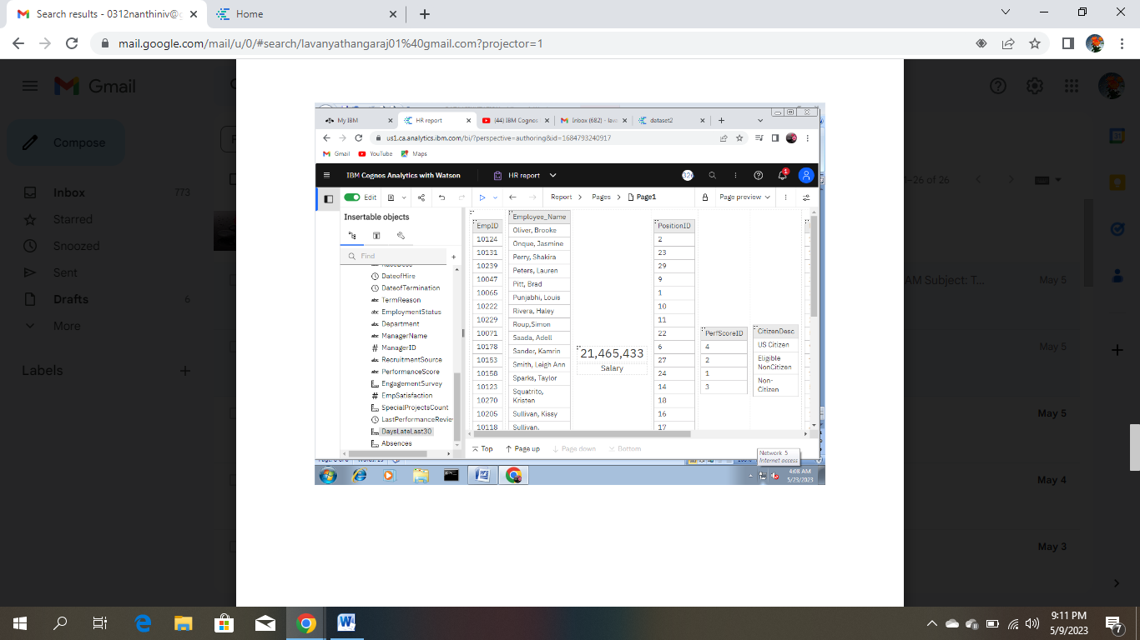

STORY:

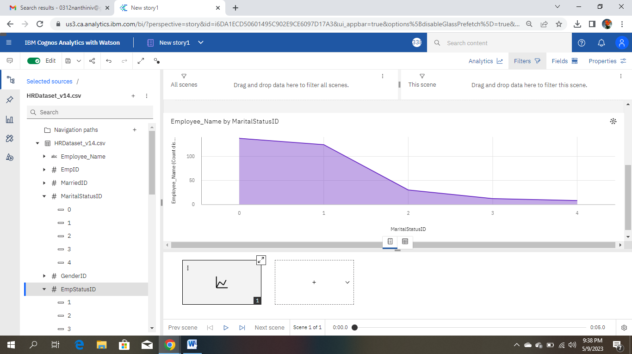

LINKL: <https://us3.ca.analytics.ibm.com/bi/?perspective=story&pathRef=.my_folders%2FNew%2Bstory1&action=view&sceneId=model0000018804fd2547_00000000&sceneTime=0>

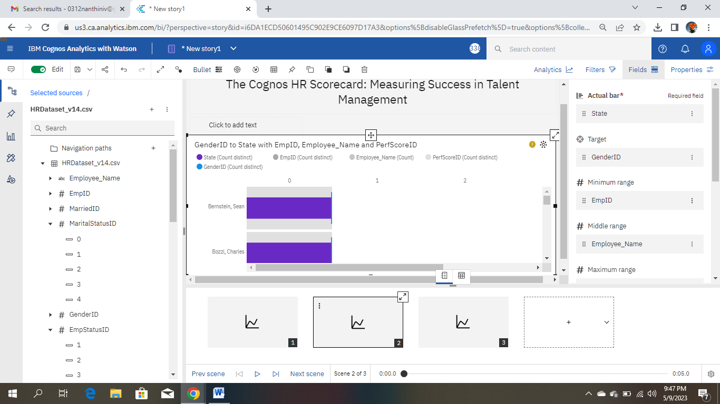LINK: https://us3.ca.analytics.ibm.com/bi/?perspective=story&pathRef=.my_folders%2FNew%2Bstory1&action=view&sceneId=model00000188050945ed_00000000&sce

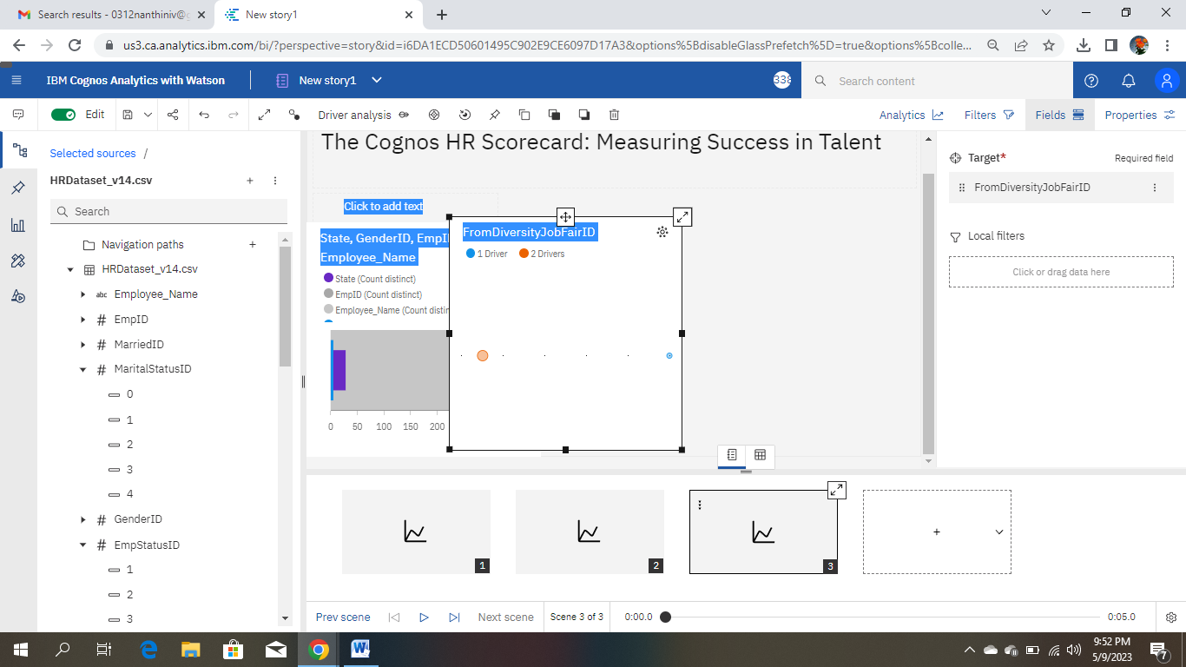

LINK: <https://us3.ca.analytics.ibm.com/bi/?perspective=story&pathRef=.my_folders%2FNew%2Bstory1&action=view&sceneId=model0000018805094674_00000000&sceneTime=0>